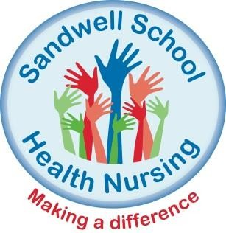If your child is due to start Reception in September 2021…
YOU ARE INVITED
TO ATTEND OUR VIRTUAL SCHOOL READINESS SESSION TAKE PART IN STORY TIME
Please contact us for information on the services we provide and how we can support with the health of your child.
- Tuesday 3rd August 2021 @ 10:00am, 12:30pm, 14:00pm and 17:00pm
- Thursday 5th August 2021 @ 10:00am, 12:30pm, 14:00pm and 17:00pm
- Tuesday 9th August 2021 @ 10:00am, 12:30pm, 14:00pm and 17:00pm
- Thursday 11th August 2021 @10:00am, 12:30pm, 14:00pm and 17:00pm
- Tuesday 16th August 2021 @ 10:00am, 12:30pm, 14:00pm and 17:00pm
- Thursday 18th August 2021 @ 10:00am, 12:30pm, 14:00pm and 17:00pm
- Tuesday 23rd August 2021 @ 10:00am, 12:30pm, 14:00pm and 17:00pm
- Thursday 25th August 2021 @ 10:00am, 12:30pm, 14:00pm and 17:00pm
Please contact Sandwell School Nursing on 0121 612 2974, or email swbh.shnsandwell@nhs.net to book on to one of the above sessions. Please note that if you do not have access to the Internet please contact us and we can arrange an alternative session for you.
Sessions include:
Bedwetting / Toileting • Healthy eating• Emotional well-being

Accident prevention• Head lice • Hygiene

